HCI Project 3

By Brian Nguyen, Woo-Jae Lee, and Cody Fulford

University of Calgary

CPSC 481 - HCI

# Affinity Diagram

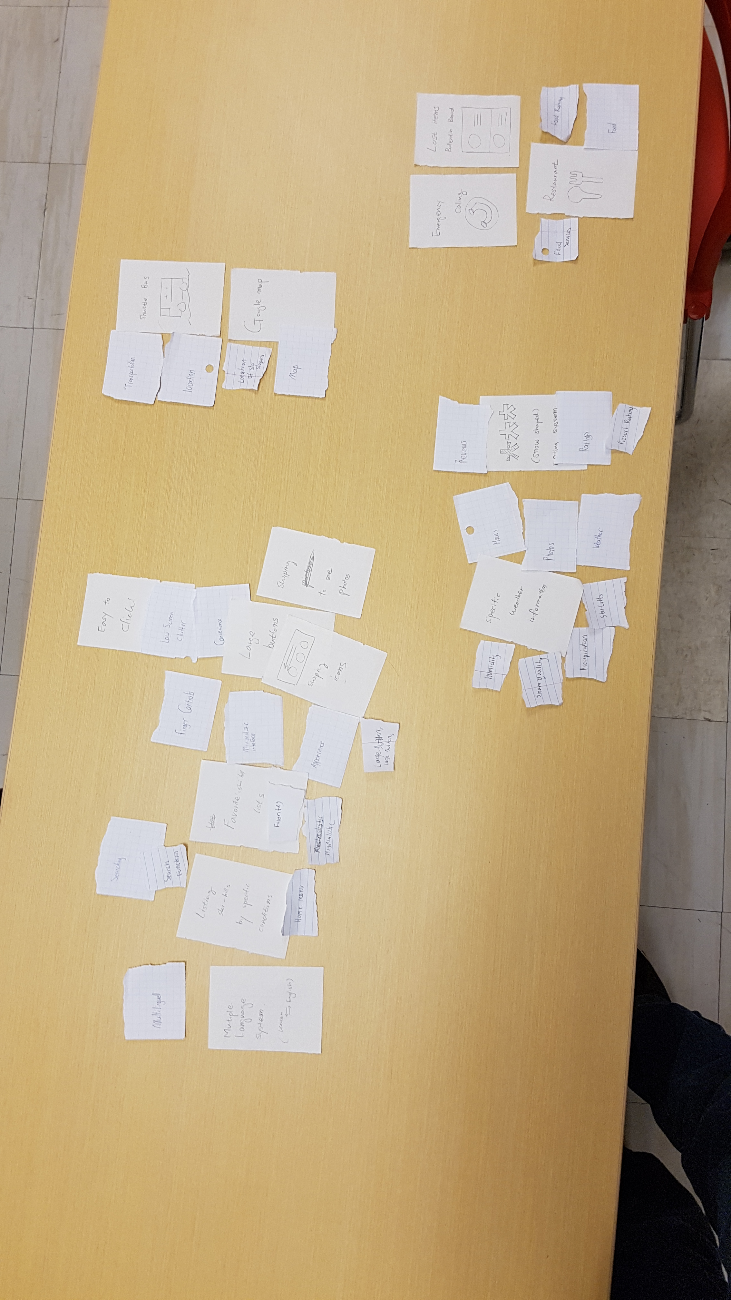

To develop our affinity diagram, we first each drew some sketches for the customer interface. We did these drawings individually so that we could bring the ideas together at the end and compare the ideas from different perspectives. Next we discussed the strengths and weaknesses of our sketches by going through them one by one. We took turns speaking about our sketches while the other group members took notes about the strengths and weaknesses of their idea. After that each group member had a list of important design concepts from the sketches. After enumerating these design concepts, we spread them across a table and grouped them up into separate categories. Initially we had eight different categories for our design concepts:

* Important application design concepts (usability, modularity)
* Skill hill information
* Ratings
* Ski hill services
* Restaurants
* Transportation
* Emergency Services
* Multiple languages support

Finally, we reduced and combined these categories into four categories:

* Skill hill information
* Services that the resort offers
* Application design (usability, modularity, ease of use)
* 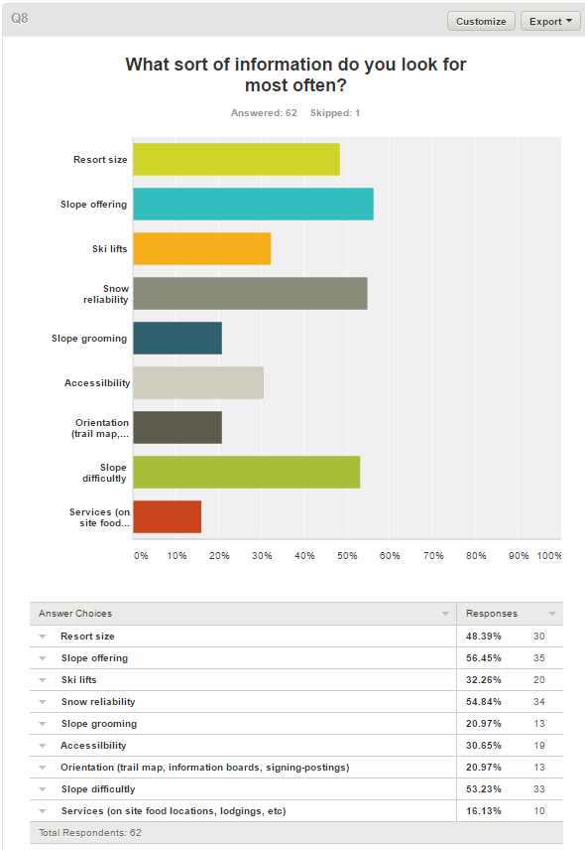Transportation (location of resort, restaurants)

Per our survey results, we could identify the major features that customers want to know about a resort. Upon reflection of our sketches, we also produced similar results namely: weather, location, ski hill availability, and price were the major features that our application must have. These features are under the skill hill information category.

We also recognized that since our users would be cold and wearing gloves most of the time, an ideal application for the users would include buttons that are large. We also thought that a minimalistic design is ideal, perhaps a main menu that includes only the essential things. These concepts were included under the application design category.

We noticed that we had several concepts related to transportation, namely resort and restaurant location, distance to the resort, and an overview of resort.

# Polished Versions

We have chosen these three designs as the most promising for satisfying our customer’s needs. The main need for our users is ease of use. This is because our users will often be in a hurry to find the information that they need, or on a ski hill where they will be, for all intents, disabled. While our customers will not actually be disabled, it is important to think of them as such because of the gloves that many skiers wear. These gloves greatly increase the size of their fingers and reduce the responsiveness of the touchscreen. Even the gloves that are specially designed to work with touchscreens increases the size of the finger. Should the customers gloves not work with the touchscreen, it is possible that they will remove the gloves to use the application. This means that the users hags will most likely be cold and shaking. These limitations that the customer will probably have sound very like what we would have to design for older people. We can also assume that the customers will be using the application with both hands since they will be standing over the snow. We assume that the customer will hold the phone with one hand and use it with the other. If the customer leaves their glove on the hand that is holding the phone, the extra bulk of their gloves will cover some portions of the screen. The area that the gloves can cover will mostly be the middle of the vertical portion of the screen, extending towards the middle of the screen. These problems have pushed us towards design concepts that emphasize speed and ease of use. All our designs use large buttons to allow people with large finders and shaky hands to easily navigate our application.

The first sketch that you can see shows how we can arrange the screen showing information about a specific ski resort in a design that accommodates both speed and ease of use for those who are wearing gloves. It accomplishes this by having large buttons that extend into the middle of the window, this allows the customer to press the buttons even while their hands are shaking or they are wearing large gloves. The other aspect that this design exemplifies is speed. If the customer is not using our application, they are not currently skiing. Since the customer is wanting to ski more than use our application, having the information for a specific ski hill be hidden behind several menus would drive customers away as threw would get frustrated with our application. What we have designed to accommodate this need is that we have placed all the information that our studies in project 1 identified as most important directly on the front page of the individual ski resort page. This means that the current weather conditions, number of open lifts, and hill rating are displayed the moment that the user opens the specific ski resorts web page. This design worked to combine both concepts of ease of use and information display.

Thee second design that we decided was most promising focuses on the design aspect of large buttons. As you can see from the sketch, the buttons that we would be using are so large it only takes a few of them to fill a screen. While this design for the hotels does not have nearly as much information concentration as the first design concept, it can be used in a slower more deliberate way. What we mean by this is that the user will be less likely to make mistakes when the buttons are as large as they are at the expense of the customer being required to tap more buttons to get to some less critical information. What this design also allows though is more high level information such as photos, or distance to a hotel. This sort of information stands out since there is less information concentration and allows the client to quickly sift through potential options. Since there is less information to sort through, it is possible that this will increase the speed that the customer can use the application.

The third sketch that we have decided has high potential supports our design concepts of low clutter and high speed of information. Since there are so few buttons on the screen, it allows the user to focus on the information on the screen while removing the possibility of a mistake. Having most the information on the screen all at one time allows a user to quickly read through it and absorb the information without needing to scroll which can lead to mistakes.

